Researching and Sketching Features for Developing a Note App

Examples of mobile apps that are used for using and keeping (academic) notes for studying, research, and everyday life:
- Microsoft OneNote:
OneNote is a free, cross-platform study notes app that offers features like a free-form text box, drawing, handwriting recognition, and audio/video recording and integrates with Microsoft Office for various useful templates.
- Apple Notes:
The app is a built-in note-taking tool for iOS and macOS devices that allows users to create, organize, and synchronise notes, photos, and files via iCloud which eliminates the need for a separate file-sharing service.
- Google Keep:
Like Microsoft OneNote, Keep is a cross-platform note-taking tool with a straightforward interface that works nicely with other Google applications, notably Google Drive. Features include voice memos, picture notes, and color-coded note labelling. It’s one of the most basic apps to write on.
- Obsidian:
Obsidian is a customisable cross-platform notes app built on Markdown, offering easy accessibility and customisation. It allows technical users to create plugins and toggle features, so it is an advanced app for tech savvies. Obsidian is a cross-platform tool suitable for daily use and offline use.
- Evernote:
It is a versatile note-taking program for students, allowing them to analyse handwritten notes and clip online content. It supports various file types, scanners, and web clippers. Evernote has an optical character reader (OCR) to convert words from photos into machine-encoded texts in the app. However, it is quite expensive with a $15 or $7 (for students) per month premium subscription.

Planned features for building a similar app in this sector:
App Name: NoteDropper
NoteDropper is a complete notetaking and organising program that helps students, researchers, and professionals organize their studying, research, and daily lives. The key features include:
- Cross-Platform Compatibility: NoteDropper synchronises flawlessly across several platforms, including smartphones, tablets, and laptops, allowing users to access their notes from any location.
- Integration with Cloud Storage: NoteDropper works with major cloud storage providers such as Google Drive, Dropbox, and iCloud, allowing users to attach files and view documents straight from the app.
- Offline Access: Allow users to access their notes when offline, with automatic synchronization when they rejoin to the internet.
- Media Support: Users may take notes using text, photos, or audio recordings, giving them more freedom to capture ideas and information.
- Organization and Tagging: NoteDropper has strong organizational features, allowing users to categorize and tag their notes for simple retrieval and maintenance.
- Customization Options: NoteDropper offers customization features, allowing users to tailor their note-taking experience through themes, templates, and formatting choices.
- Handwriting and Drawing Tools: Incorporate features for handwriting recognition and drawing, useful for users who prefer to sketch diagrams or jot down handwritten notes.
- Collaboration Tools: Users may interact with peers or coworkers by exchanging notes and working on them in real time, which promotes collaboration and productivity.
- Flashcard Generation: Users can easily build flashcards from their notes and course slides to help them study and comprehend.

User usage of the proposed app:
- Nicholas Lyson (Student): Nicholas will use NoteDropper to organize his academic commitments. He begins each day by reviewing yesterday's lecture notes and adding items to his to-do list. During lectures, he takes detailed notes in NoteDropper's numerous formats. In between lectures, he swiftly examines and edits his notes before collaborating with classmates in study groups via shared notebooks. In the evening, he prepares flashcards for future tests and writes about his day in the journal function.
- Study Group Participants: A group of students like from Nicholas' class would utilise NoteDropper to work on a collaborative assignment. They construct a shared notebook where they may submit ideas, discuss resources, and assign responsibilities. NoteDropper's real-time synchronization guarantees that everyone has access to the most recent updates, promoting effective cooperation and efficiency.
- Educators: NoteDropper allows educators to develop interactive lecture materials, exchange course information with students, and encourage collaborative learning activities. The program allows them to annotate lecture slides, record audio explanations, and engage students in conversations. Using NoteDropper's assessment tools, educators may construct quizzes, track student progress, and give individualized feedback to improve learning outcomes. Educators may also utilize the app to stimulate student reflection, measure engagement, and discover opportunities for instructional improvement.
- Researcher: Researchers may use NoteDropper to simplify their research processes. They can take extensive notes during conferences, seminars, and research sessions and categorize them into folders depending on projects or subjects. The app's collaboration function allows academics to easily interact with peers, exchange insights, and co-author publications. Researchers may also create reminders for deadlines, experiments, and data analysis to keep them on track with their research objectives. The flashcard tool is greatly beneficial for summarizing significant facts and concepts, which may help you prepare presentations and academic papers.
- Professional: Professionals may use NoteDropper to organize meeting notes, brainstorm project ideas, and stay on top of essential work and deadlines. They may synchronise their notes across many devices to provide easy access to information while on the road.
- Regular Users: NoteDropper's organising and note-taking functions are useful to both casual users. They may use the app to keep track of personal duties, scribble down ideas, and work with friends and family on tasks and events.

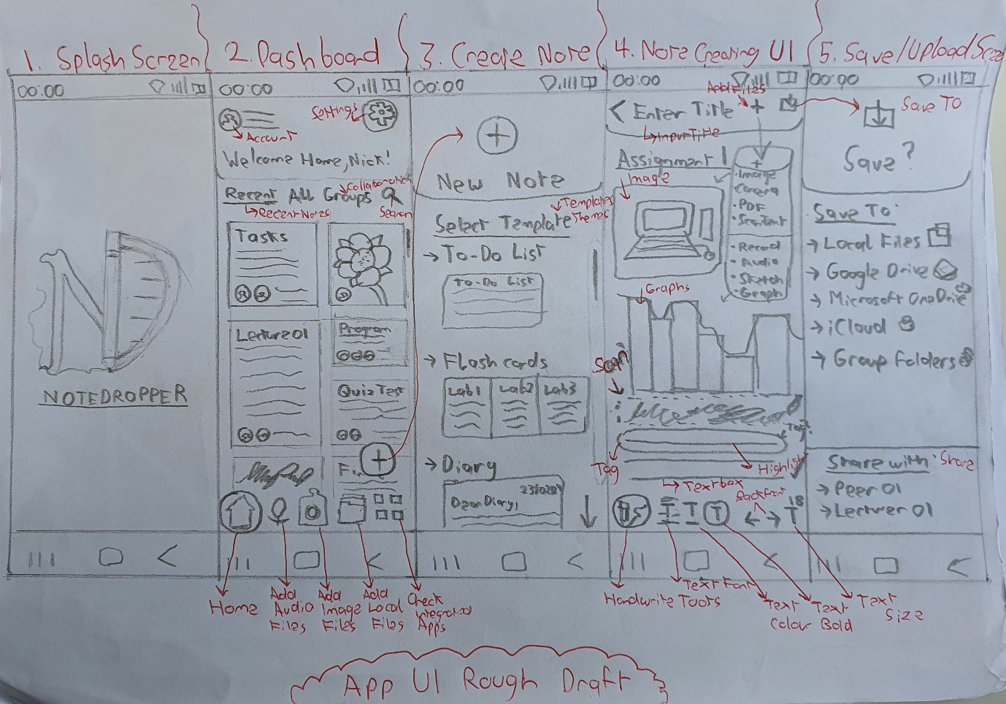

User Persona
Name: Nicholas Lyson
Age: 20
Occupation: Student
Device: Samsung S23 Ultra
Background:
Nicholas Lyson is a second-year college student doing a major in Computer Science. He lives a busy life, managing scholastic duties, extracurricular activities, and personal commitments. He relies heavily on Microsoft Apps on his smartphone to successfully manage his schedule and keep organized. Nicholas is committed to succeeding in his academics and continually finds ways to improve his learning process.
"I aspire to thrive academically while balancing my obligations and passions, adopting technology to optimise my study routines."
Goals/Motivations:
- Academic Excellence: Nicholas is motivated by the ambition to excel in his computer science studies. He attempts to retain excellent marks while also deepening his comprehension of complicated ideas. Nicholas appreciates efficiency in how he manages his time and duties. He seeks tools and tactics that can help him optimize his workflow and do more in less time.
- Collaboration: Nicholas understands the value of teamwork in learning. He regularly engages in study groups and online forums to share ideas, clarify doubts, and learn from his peers.

- Tech-Savvy: Nicholas can leverage technology, particularly mobile applications, to boost his academic efficiency. He is skilled at understanding complex software and using its capabilities to optimize his process.
- Reflection: Nicholas feels that reflection may help people improve personally. He keeps a regular record of his ideas and experiences, which allows him to look back on his success and find areas for growth.
Frustrations:
- Time Constraints: With his demanding schedule, Nicholas struggles to find time for all his academic and extracurricular activities. He feels pressured to manage his different obligations while maintaining quality.
- Information Overload: Nicholas finds it hard to keep up with the many course materials, tasks, and deadlines available. He is looking for tools that will allow him to properly organise and prioritize information.
- Retention Challenges: Nicholas struggles to remember and recollect knowledge, particularly after intensive study sessions. He seeks methods such as flashcards to improve his understanding and memory recall.

Sources:
- Microsoft OneNote - Your digital notebook
https://www.microsoft.com/en-us/microsoft-365/onenote/digital-note-taking-appg
- 5 Ways to Empower your Students with OneNote
https://thejenalleeshow.com/2020/04/19/5-ways-to-empower-your-students-with-onenote/
- The effect of mobile learning applications on students' academic achievement and attitudes toward mobile learning
https://files.eric.ed.gov/fulltext/EJ1174817.pdf
- Note Taking With Technology
https://www.edutopia.org/blog/the-4ss-of-note-taking-beth-holland
- 20 Best Note-Taking Apps Every Student Needs in 2024
https://amberstudent.com/blog/post/best-note-taking-apps-every-student-needs#7-evernote
- The best note-taking apps for collecting your thoughts and data
https://www.theverge.com/23942597/notes-text-evernote-onenote-keep-apps
- Evernote Reviews & Product Details
https://www.g2.com/products/evernote/reviews#survey-response-8796881

User Scenario
Nicholas Lyson (20) is a second-year college student studying computer science. He manages a rigorous schedule that includes classes, lab work, and some extracurricular activities in the late days. Nicholas relies mostly on his smartphone to try to efficiently handle his academic responsibilities.
In the early morning, he wakes up to his alarm, checking his alerts, which include reminders from Moodle about his first lecture. He reads the notes he took down in Microsoft OneNote to review what he learned such as from yesterday's Algorithms and Data Structure lesson which checks the critical parts of it and refreshes his recollection on the following themes. Nicholas adds chores to his to-do list in the app, such as finishing his lab assignment for this week.
During the lectures, Nicholas uses OneNote to take live notes throughout his course, inputting key concepts, pictures, and lecturer explanations. To ensure clarity and ease of access, he spends his time organising his copies into distinct folders inside there and uploading them in OneDrive, with each course having its own. In breaks after some lectures, Nicholas reviews again to see what he just wrote to add current ideas and update his to-do list. After he does all that for a small fraction of his breaks, he attends a study group in the college library or in Microsoft Teams where he and his peers share what they took down from the lectures and contribute to each other to further understand the topics. Nicholas then goes to his Video Game Society meetups before he comes back home from campus if he has time.
Nicholas develops flashcards in OneNote from his notes and the lecture slides that are uploaded in Moodle throughout the evening at home to help him prepare for his lab quizzes in his Software Engineering module. He tests himself on them to reinforce his comprehension of the content. Every time before going to bed, Nicholas records a journal account in the app to reflect on his day and scribble down thoughts, ideas, and places for development. He finally sets more reminders for tomorrow's work and lectures to help him keep on top of his academic commitments.

